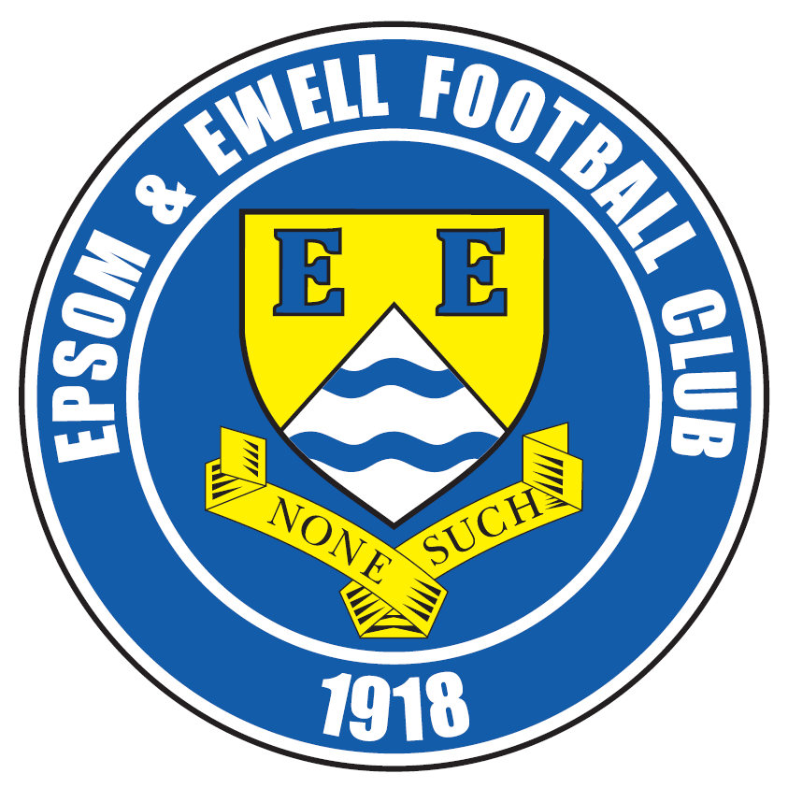 | Epsom & Ewell F.C.  2  v  Chertsey Town  Tuesday, 15th August 2017 – 7.45 p.m.
Good evening and welcome to High Road for our opening home match of the season. We welcome the players, supporters and officials of Chertsey Town for what is the two clubs’ 50th meeting. We hope they enjoy the game but not the result!

We defeated our opponents on both occasions last season to record a very rare double over them. Historically though, we have a poor record against our Surrey neighbours, even if it has improved notably in recent years and we will be visiting Alwyns Lane later this season trying to win our fifth straight match there!

However, that is for the future and for now we must concentrate on taking the points on offer here. We obviously started the season with a disappointing defeat by Banstead Athletic in the F.A. Cup and can have few complaints at the result. Then on Saturday we visited Green Lane for the first time for a League battle with CB Hounslow United and despite taking the lead with a superb Joe Loftus-Cheek strike we had to settle for a 4-2 defeat. However, it must be remembered that we have a number of new players and given time I am sure they will become better as a team as they become more familiar with each other.

We have no fixture this Saturday and on Monday we make the short journey to play Sutton Common Rovers at Sutton United, unless they draw their F.A. Cup tie with Eastbourne Town, so keep looking out for the results on Saturday or check out our Twitter feed as you don’t want a wasted trip there! The website will not be updated this weekend.

We then visit Colliers Wood United on the Friday evening before reacquainting ourselves with Banstead Athletic once again at Merland Rise on the Bank Holiday Monday morning.

Our next home game is tough to call right now. We are scheduled to play Redhill in the League on 2nd September, but Chipstead are also at home in the League, so the provision is there for the match to be switched to Redhill instead. If Chipstead defeat Horley Town on Saturday in the F.A. Cup and are then drawn away, the match may still take place here. However, if Redhill win their Cup match at home to new Isthmian League club Ashford United, then the match will be off completely regardless of Chipstead’s result. All very confusing!

About the only thing that is certain right now is that we host Spelthorne Sports on Saturday 9th September and host Horley Town three days later, so it won’t be long until we are back at High Road! Then again, why not follow us away from home too? It’s not very far to go in this League!

Enjoy the game.

Rich

Don’t forget, you can follow us on Facebook: www.facebook.com/epsomandewellfc
Twitter: @EEFCOfficial Instagram at: www.instagram.com/epsomandewellfc
and Youtube at: www.youtube.com/channel/UCtLrpS0x5OaYUACRT34_zng

Cover photos by Gemma Jarman to mark 10 years since Kyle Hough’s debut

- Kyle scores goal number 202 for the club in Saturday’s defeat at CB Hounslow

- Kyle scores his 48th goal for us at Cove in October 2009

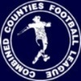
Cherry Red Records Combined Counties League
Premier Division Table 2017/18
inc Saturday 12th August | P | W | D | L | F | A | Pts | GD | H | A
Westfield | 1 | 1 | 0 | 0 | 5 | 0 | 3 | +5 | 14/4 | 9/12
CB Hounslow United | 1 | 1 | 0 | 0 | 4 | 2 | 3 | +2 | 13/2 | 2-4
Spelthorne Sports | 1 | 1 | 0 | 0 | 3 | 1 | 3 | +2 | 9/9 | 27/1
Camberley Town | 1 | 1 | 0 | 0 | 3 | 1 | 3 | +2 | 10/3 | 14/10
AFC Hayes | 1 | 1 | 0 | 0 | 2 | 0 | 3 | +2 | 28/4 | 18/11
Abbey Rangers | 1 | 1 | 0 | 0 | 3 | 2 | 3 | +1 | 16/12 | 17/2
Godalming Town | 1 | 1 | 0 | 0 | 2 | 1 | 3 | +1 | 11/11 | 13/1
Guildford City | 1 | 1 | 0 | 0 | 1 | 0 | 3 | +1 | 2/12 | 7/4
Bedfont Sports | 1 | 0 | 1 | 0 | 2 | 2 | 1 | 0 | 24/3 | 4/11
Knaphill | 1 | 0 | 1 | 0 | 2 | 2 | 1 | 0 | 24/2 | 7/10
Hanworth Villa | 1 | 0 | 1 | 0 | 1 | 1 | 1 | 0 | 23/9 | 10/2
North Greenford United | 1 | 0 | 1 | 0 | 1 | 1 | 1 | 0 | 28/10 | 17/3
Walton & Hersham | 1 | 0 | 1 | 0 | 1 | 1 | 1 | 0 | 30/12 | 21/4
Colliers Wood United | 1 | 0 | 1 | 0 | 1 | 1 | 1 | 0 | 30/3 | 25/8
Banstead Athletic | 1 | 0 | 0 | 1 | 2 | 3 | 0 | -1 | 2/4 | 28/8
Redhill | 1 | 0 | 0 | 1 | 1 | 2 | 0 | -1 | 2/9 | 6/1
Chertsey Town | 1 | 0 | 0 | 1 | 0 | 1 | 0 | -1 | 15/8 | 31/10
Epsom and Ewell | 1 | 0 | 0 | 1 | 2 | 4 | 0 | -2 | X | X
Sutton Common Rovers | 1 | 0 | 0 | 1 | 1 | 3 | 0 | -2 | 3/2 | 21/8
Balham | 1 | 0 | 0 | 1 | 1 | 3 | 0 | -2 | 20/1 | 25/11
Horley Town | 1 | 0 | 0 | 1 | 0 | 2 | 0 | -2 | 12/9 | 23/12
Farnham Town | 1 | 0 | 0 | 1 | 0 | 5 | 0 | -5 | 14/11 | 16/9
1

Lucky Day? – 15th August
Played 4 - Won 2 Drawn 0 Lost 2 - For 9 Against 14 - PPG 1.50 - Average
Our Club record against today’s opponent
Played 49 - Won 19 Drawn 5 Lost 25 - For 75 Against 87 - PPG 1.27 - Below Average
Our Largest wins and losses against today’s opponent
Won 3-0 - on four separate occasions
8th March 1994 - L 0-7 - Isthmian League Associate Members Trophy QF (H)
Their Last Visit
17th December 2016 - Won 2-1 - Combined Counties League

First Eleven Appearances 2017/18 - (max 2)
Name | Debut | 2016/17 |  |  |  | Career Totals
Name | Debut | App | Sub | Total | Goals | App | Sub | Total | Goals
AJAYI Tayo | 06/08/2017 | 2 | 0 | 2 | 0 | 2 | 0 | 2 | 0
BROOKS Jordan | 06/08/2017 | 2 | 0 | 2 | 0 | 2 | 0 | 2 | 0
CASTELL Cristian | 06/08/2017 | 2 | 0 | 2 | 0 | 2 | 0 | 2 | 0
DEWAR Ali | 29/10/2011 | 0 | 1 | 1 | 0 | 55 | 41 | 96 | 10
DYSON Ben | 12/08/2017 | 1 | 0 | 1 | 0 | 1 | 0 | 1 | 0
GRIFFIN Reisse | 08/08/2015 | 1 | 0 | 1 | 0 | 74 | 13 | 87 | 6
HARLAND-GODDARD Tom | 06/08/2017 | 1 | 1 | 2 | 0 | 1 | 1 | 2 | 0
HARRIS Colin | 04/08/2012 | 2 | 0 | 2 | 0 | 27 | 0 | 27 | 0
HATFIELD Jamie | 11/11/2006 | 0 | 0 | 0 | 0 | 249 | 13 | 262 | 6
HAYWARD Ben | 07/03/2007 | 1 | 0 | 1 | 0 | 244 | 28 | 272 | 18
HENDRY Rob | 08/08/2015 | 2 | 0 | 2 | 1 | 70 | 22 | 92 | 24
HOUGH Kyle | 14/08/2007 | 1 | 1 | 2 | 1 | 334 | 20 | 354 | 202
JARMAN Mark | 08/08/2009 | 0 | 0 | 0 | 0 | 136 | 51 | 187 | 76
LAW Franky | 06/08/2017 | 2 | 0 | 2 | 0 | 2 | 0 | 2 | 0
LOFTUS-CHEEK Joe | 06/08/2017 | 2 | 0 | 2 | 1 | 2 | 0 | 2 | 1
MARVELL Dale | 15/01/2000 | 1 | 0 | 1 | 0 | 270 | 49 | 319 | 86
MCKAY Alex | 20/12/2008 | 0 | 0 | 0 | 0 | 131 | 37 | 168 | 12
MYERS Antony | 23/12/2006 | 0 | 0 | 0 | 0 | 75 | 33 | 108 | 9
NWACHUKWU Jason | 01/10/2016 | 0 | 1 | 1 | 0 | 17 | 17 | 34 | 1
O'BRIEN Louis |  | 0 | 0 | 0 | 0 | 0 | 0 | 0 | 0
ROBERTS Liam | 12/08/2017 | 0 | 1 | 1 | 0 | 0 | 1 | 1 | 0
ROBINSON Matt | 01/12/2012 | 0 | 0 | 0 | 0 | 21 | 5 | 26 | 5
ROBINSON Sam | 22/10/2011 | 1 | 0 | 1 | 0 | 62 | 6 | 68 | 14
ROSE Daniel | 25/10/2016 | 1 | 0 | 1 | 0 | 3 | 5 | 8 | 0
SMITH Matt | 08/08/2009 | 0 | 0 | 0 | 0 | 91 | 46 | 137 | 11
THOMPSON Elliott | 09/02/2016 | 0 | 0 | 0 | 0 | 7 | 9 | 16 | 1
TURPIE Alistair | 31/03/2016 | 0 | 0 | 0 | 0 | 11 | 1 | 12 | 0

Results and Fixtures so far
Emirates F.A. Cup – Extra Preliminary Round – Saturday 5th August
Abbey Rangers | 0-3 | Cray Valley (PM)
Camberley Town | 0-0 | Blackfield & Langley
Colliers Wood United | 2-2 | Uckfield Town
Farnham Town | 3-2 | Fawley
Godalming Town | 2-1 | Westfield
Hailsham Town | 1-8 | Redhill
Hanworth Villa | 5-0 | Bedfont & Feltham
Haywards Heath Town | 1-1 ABANDONED | Bedfont Sports
Holmer Green | 4-0 | AFC Hayes
Horley Town | 5-1 | Raynes Park Vale
Knaphill | 0-0 | Bournemouth
Newport (IOW) | 2-2 | Guildford City
Rusthall | 0-0 | CB Hounslow United
Spelthorne Sports | 1-3 | Chertsey Town
Sutton Common Rovers | 2-0 | Canterbury City
Walton & Hersham | 7-0 | Mile Oak
Welwyn Garden City | 2-4 | North Greenford United
Emirates F.A. Cup – Extra Preliminary Round – Sunday 6th August
Epsom & Ewell | 1-2 | Banstead Athletic
Emirates F.A. Cup – Extra Preliminary Round – Tuesday 8th August
Haywards Heath Town | 5-2 | Bedfont Sports
Emirates F.A. Cup – Extra Preliminary Round Replay – Tuesday 8th August
Blackfield & Langley | 1-2 | Camberley Town
Uckfield Town | 0-2 | Colliers Wood United
Bournemouth | 0-2 | Knaphill
CB Hounslow United | 2-1 | Rusthall
Combined Counties League – Saturday 12th August
AFC Hayes | 2-0 | Horley Town
Balham | 1-3 | Spelthorne Sports
Banstead Athletic | 2-3 | Abbey Rangers
Bedfont Sports | 2-2 | Knaphill
CB Hounslow United | 4-2 | Epsom & Ewell
Chertsey Town | 0-1 | Guildford City
North Greenford United | 1-1 | Colliers Wood United
Redhill | 1-2 | Godalming Town
Sutton Common Rovers | 1-3 | Camberley Town
Walton & Hersham | 1-1 | Hanworth Villa
Westfield | 5-0 | Farnham Town
Combined Counties League – Monday 14th August
Abbey Rangers | V | Bedfont Sports
Combined Counties League – Tuesday 15th August
Camberley Town | V | CB Hounslow United
Epsom & Ewell | V | Chertsey Town
Farnham Town | V | Walton & Hersham
Godalming Town | V | Balham
Hanworth Villa | V | North Greenford United
Horley Town | V | Westfield
Results and Fixtures so far
Combined Counties League – Tuesday 15th August
Knaphill | V | Sutton Common Rovers
Spelthorne Sports | V | AFC Hayes
Emirates F.A. Cup – Extra Preliminary Round Replay – Wednesday 16th August
Guildford City | V @ Godalming | Newport (IOW)
Combined Counties League – Wednesday 16th August
Colliers Wood United | V | Redhill
Emirates F.A. Cup – Preliminary Round – Saturday 19th August
Baldock Town | V | North Greenford United
Banstead Athletic | V | Loxwood
Carshalton Athletic | V | Walton & Hersham
Chertsey Town | V | Horsham
Chipstead | V | Horley Town
Colliers Wood United | V | Shoreham
Godalming Town | V | Farnham Town
Laverstock & Ford | V | Knaphill
Newport (IOW) / Guildford City | prov | Camberley Town
Ramsgate | V | Hanworth Villa
Redhill | V | Ashford United
Sutton Common Rovers | V | Eastbourne Town
Tunbridge Wells | V | CB Hounslow United
Combined Counties League – Saturday 19th August
Bedfont Sports | V | AFC Hayes
Combined Counties League – Monday 21st August (subject to FA Cup replays)
Sutton Common Rovers | V | Epsom & Ewell
Combined Counties League – Tuesday 22nd August (subject to FA Cup replays)
Abbey Rangers | V | Godalming Town
Camberley Town | V | Walton & Hersham
Chertsey Town | V | Westfield
Hanworth Villa | V | CB Hounslow United
Horley Town | V | Balham
Spelthorne Sports | V | Redhill
Combined Counties League – Wednesday 23rd August (subject to FA Cup replays)
Colliers Wood United | V | Guildford City
Combined Counties League – Friday 25th August
Colliers Wood United | V | Epsom & Ewell
Combined Counties League – Saturday 26th August
AFC Hayes | V | Hanworth Villa
Balham | V | Banstead Athletic
CB Hounslow United | V | North Greenford United
Chertsey Town | V | Bedfont Sports
Farnham Town | V | Spelthorne Sports
Godalming Town | V | Knaphill
Guildford City | V | Horley Town
Redhill | V | Sutton Common Rovers
Walton & Hersham | V | Abbey Rangers
Westfield | V | Camberley Town

From behind the goal
Epsom & Ewell 1-2 Banstead Athletic
Emirates F.A. Cup - Extra-Preliminary Round - Sunday 6th August 2017

Depressing opening to the season at High Road

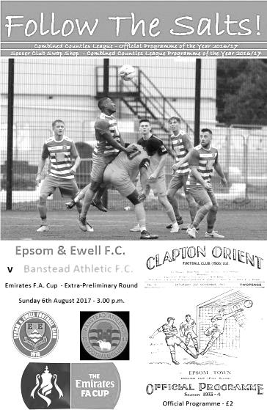
It is difficult to imagine a more disappointing start to any season than to depart the F.A. Cup in your opening match. However, many clubs suffered that fate over the weekend and we became another as we hosted and were defeated by newly promoted Banstead Athletic on Sunday afternoon.

And it has to be said that they were full value for their victory as a virtually new team takes time to bed in and the visitors took full advantage, finding gaps and exploiting them with some nice football, clinically finished off by new striker Leo Medrado who had joined them from AC London in the close season.

For our part Glyn gave six players their debut; the highest number on any given day since an opening day victory against Farnham Town in 2014 and we also saw some old faces returning. At the back Ben Hayward played his first game for us in over three years, with Colin Harris in goal making his first appearance for us since a nasty hand injury in December 2012. Additionally, more recent members of the Salts, Sam Robinson and Kyle Hough also returned after brief spells away, Hough entering from the bench in the second half. However, there was very little familiarity about our line-up with only Reisse Griffin remaining from the team that finished the season in the League Cup Final just three months and one day previously.

Bearing this in mind, I think everyone expected this to be a tough encounter, but to go behind after 50 seconds was the stuff of nightmares. Many were just taking their seats when Medrado finished off a loose ball into the bottom corner from about 15 yards with the ball seeming to creep between Harris and his left hand post.

Echoes of our Cup disaster against Erith & Belvedere began to surface where we had also conceded in the opening minute, but this time we would be back on terms fairly quickly after new signing from Leatherhead Academy Joe Loftus-Cheek ran onto a Griffin through ball and got in front of his man who then ran into the back of him and brought him down in the box in the 6th minute. There were complaints about the decision but I really couldn't see why, although it should be noted that the referee didn't book the offender and gave the penalty on the advice of the Assistant, so maybe he wasn't totally convinced himself. After a break for defender Robert Hill to receive

treatment for a facial injury, Rob Hendry stepped up and slotted away the penalty clinically with the clock showing the 9th minute.

Hill continued to require treatment, using the 3, 13 and finally the number 12 shirts before the bleeding finally stopped but we didn't really take advantage of the situation. In fact they had more chances in the opening half. Both teams dragged a shot across the face of the goal from good positions and another good run on the right wing resulted in a low cross that Harris was able to get a hand to, or there would have been a certain goal otherwise. In the 33rd minute Harris produced a superb save as a deep free kick was inexcusably met by a free header that sent the ball right into the top corner, only to see Harris claw the ball away at the last moment.

We needed to improve but nearly conceded in the 49th minute when a right wing cross was met by a thumping header that flew back off our crossbar, although we had a decent shout for another penalty when new signing Tayo Ajayi beat his man but ended up dumped on his backside. It's not often that you get two penalties awarded to the same team in a match though, and the referee wasn't going to give this one.

This was a pity as we didn't really look like scoring that often from that point. In fact we were fortunate to see a low shot come back off Harris' left hand post after 76 minutes after we had been caught out by a long ball. A couple of minutes later Harris was beaten but a defender was able to clear a goalbound shot away from the danger area and thoughts began to turn to whether we could hold on for a replay, rather than whether we could win the match.

And in the end we couldn't as Medrado picked the ball up on the right and scooted past three rather average challenges to then slam the ball past Harris from about 12 yards in the 83rd minute. They nearly made it three-one after a poor shot had been dragged across goal but it fell straight in the path of their left winger who put the ball into the side netting from about 8 yards out with just Harris to beat. Our final chance came and went with a deep free kick that Hough managed to flick on but it went straight into the keeper's arms.

On another day we might have ridden our luck better and held on for the replay but we didn't have enough of the ball to really say we deserved one. In fact, had the score been 1-4 we could have had no complaints. Things will improve as our squad becomes more familiar with each other, but this cup tie came just too soon for us and it is of some relief that we are exempted in the Vase until October, by which time it is hoped we will have become a better unit.

Epsom and Ewell: Colin Harris, Jordan Brooks, Cristian Castell, Franky Law,
Reisse Griffin, Daniel Rose, Ben Hayward, Sam Robinson ©, Tayo Ajayi,
Joe Loftus-Cheek, Rob Hendry

Subs: Kyle Hough for Ajayi (73), Tom Harland-Goddard for Rose (78)

Referee: A.Connor
Attendance: 123

#
From behind the goal
CB Hounslow United 4-2 Epsom & Ewell
Combined Counties League - Premier Division - Saturday 12th August 2017

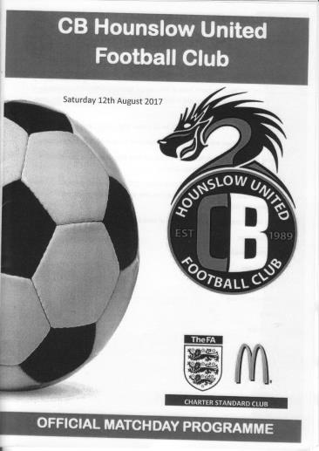
Dragons burn Salts in opening League encounter

Despite bookending this match with the first and last goals, the newly homed CB Hounslow United scored four times in between to claim all three points on offer in the very first League match played at Green Lane.

The neat new ground was in understandably perfect condition, although strangely only a small crowd were present to witness this historic match for the home team and in view of this, it was always going to be a difficult match to win. Maybe the plan would be to capitalise on any early nerves they might have and see if we could go from there, and it worked out exactly like that for a while.

In terms of personnel, almost our entire midfield was missing from last week as Sam Robinson, Daniel Rose, Reisse Griffin and Ben Hayward were all away, so Ben Dyson, Tom Harland-Goddard, Dale Marvell and Kyle Hough all came into the starting eleven. There was a large amount of youth and experience on display for us in this match. For Hough, it was appearance 354 and Marvell 319, while for Dyson it was his debut and in an unfamiliar defensive midfield role, having spent much of pre-season in defence.

The opening exchanges were fairly even and Rob Hendry latched onto a good ball in from Tayo Ajayi but the keeper Kyle Cherry was there to smother the chance, then Colin Harris was required to make a low early save, but it was all fairly routine stuff as the twenty-two players got used to the surroundings. Hendry sent a free kick over the bar from nearly thirty yards out, while in response Harris made another save from a long range shot and the danger was eventually cleared.

The game was fairly tame to this point but then Joe Loftus-Cheek produced some real quality to open the scoring in the 21st minute. A fine pass from Marvell into the left hand channel was picked up by our young striker who beat his man before cutting inside another and blasting the ball into the far top corner from the edge of the penalty area. It was a quite stunning strike and worthy of winning any match, although, regretfully that wouldn't be the case this time.

The goal seemed to wobble the home team for a spell as we started to grow in confidence. In fact, we could have had a penalty when a Hendry free kick was delivered to the far post where the defender was all over Harland-Goddard who was badly impeded. Hough then saw his shot on target blocked out for a corner before Harland-

Goddard made a good run to the edge of the box, but his shot on goal didn't trouble the keeper.

Arguably the turning point of the match came shortly after this. Ajayi and Hendry had switched wings and both were having success but as Ajayi ran the ball out of play he pulled up with a slight injury. He walked back to the pitch but instead of going back on, he sat just by the side of it for some reason. As a result, the home side had a man advantage, and while we were short they attacked and using the extra man, produced

an overlap on the right from Chris Henry who drilled the ball past Harris from a narrow angle in the 36th minute. Henry has been scoring goals against us for a decade now for various clubs, but if Ajayi had stayed on the field the referee would not have been able to restart the game when he did and we would have still been ahead.

Now it was our turn to wobble and a powerful shot was diverted on goal and fortunately straight to Harris, but in first half injury time, they broke through on the left wing and a low cross to the near post was met first by Charlie McKee who got there just ahead of the defensive challenge to steer the ball past Harris from six yards.

We needed a good response in the second half and nearly got it. Ajayi sent in a great cross from the right wing but the ball was headed wide from only eight yards wide, while in the 51st minute an expertly delivered Hendry cross looked like it was going to be headed in by any of three of our players. In fact maybe Franky Law was distracted by the presence of the others and was unable to divert it on target from just six yards out. Yet again we paid for it almost immediately as their striker broke down the right wing and pulled the ball back for McKee to hook the ball in off the far post from about ten yards out with the clock showing the 52nd minute.

Harland-Goddard and Dyson had shots as did substitute Ali Dewar, but they still looked the more dangerous and we lost the ball in midfield which directly led to the fourth goal, McKee strolling through the middle in the 70th minute and calmly finishing beyond Harris. We introduced Jason Nwachukwu who provided a spark and we pressed for another goal of our own. Substitute Liam Roberts had his shot deflected for a corner but was well off target with a free kick from a dangerous position. However, we did pull a goal back in the 86th minute when a long throw wasn't cleared and Hough drilled the loose ball into the net from ten yards.

CB Hounslow are a team that play well when they are confident. To start with we restricted that confidence, but mistakes let them off the hook and by the end they were worthy winners. It doesn't help when your entire midfield isn't available from the previous week, but it is all good experience for the youngsters and I'm sure we will settle down to play some nice football sooner rather than later. Patience is the key this season for Salts supporters.

Epsom and Ewell: Colin Harris (c), Jordan Brooks, Cristian Castell, Franky Law, Dale Marvell, Tom Harland-Goddard, Ben Dyson, Tayo Ajayi, Joe Loftus-Cheek, Kyle Hough, Rob Hendry

Subs: Ali Dewar for Ajayi (55), Liam Roberts for Hendry (71),
Jason Nwachukwu for Harland-Goddard (77)

Ten Years ago yesterday!
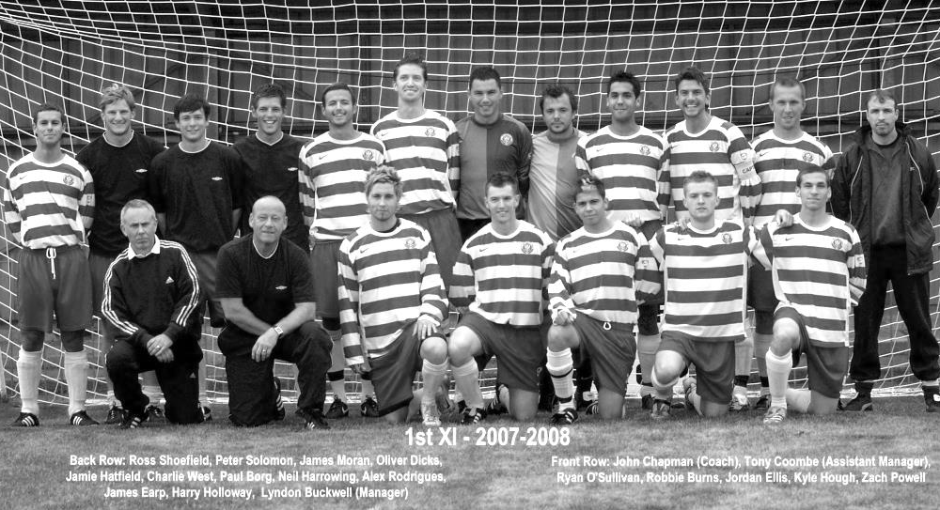
On Tuesday evening, 14th August 2007, or if you like, ten years ago yesterday, two strikers made their debuts for the Salts in a League match against Colliers Wood United at Merland Rise, where we were sharing with Banstead Athletic. We lost 2-1 and neither scored, but it wouldn’t be long before both would join the elite club that previously had just six players in history who have scored over 100 goals for our club. They were Robbie Burns and Kyle Hough.

Our fairly new Manager at the time, Lyndon Buckwell had steered us to safety, joining midway through the 2006/07 season and by adding them to our squad, along with a few other notable

players like keeper Paul Borg, defenders Charlie West and Nick Drew and midfielder James Earp, we had six players making their debuts that evening, all of whom, except Drew, are in the picture taken on 18th August 2007 below.

Of course, they were expected to make their debuts on the first Saturday of the season at tonight’s opponents Chertsey Town, but the match had been postponed as the referee decided that ruts left by Chertsey’s close season drainage works were dangerous!

Of the six players, Earp didn’t stay long but the other five were to stay for a while with four of them passing 150 appearances for us. Borg was a superb keeper while West was a dominant defender in the air, both with plenty of experience but Robbie and Kyle were a very prolific strike pairing; the best at the club since Steve Hill and Tommy Tuite in the early to mid-eighties.

Burns was the first of the pair to reach the hundred mark in a midweek 4-3 win at Colliers Wood United on 24th October 2012 with Hough following on 5th January 2013 by which time we were on a run of league wins that would eventually become a club record of 12 and although promotion fell to Guernsey and Egham (including a keeper by the name of Borg) we went on to win the League Cup in 2013 by beating South Park 3-0 at Farnborough F.C. with both players on the score sheet and Kyle opening the scoring by beating the keeper to a through ball and knocking the ball into an empty net (see across the page).

Robbie’s goal was his 120th for the club, but incredibly he would only score one more for us as his career tailed off notably from that point. Despite being only 28, issues off the field and a notable dislike of training meant that he joined the team late in 2013/14, scoring once at Sandhurst with a cheeky back flick. He only made the nine appearances that year and although he returned briefly in 2014/15 he decided to pack it in following a league match at Raynes Park Vale in 2015.

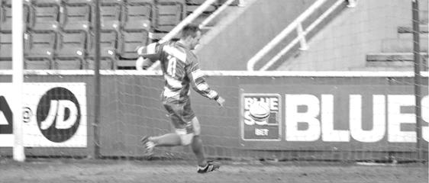
Kyle would go on from strength to strength, first passing Robbie’s mark of 121 goals before sailing past the marks of Steve Hill (127) and 1930’s star Jimmy Jones (148) to assume third place on the all-time goal scorers list. Then in April 2016 he reached the 200 goal mark for our club with a strike at Hanworth Villa (see below). I haven’t even mentioned his 47 penalties from 51 attempts yet! No one else in club history even has twenty!

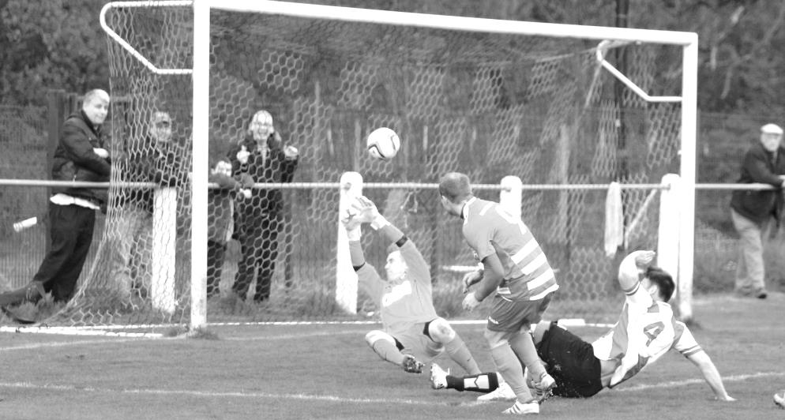
He had a season at Horley Town last year but is now back just in time to mark the ten year anniversary and it is also pleasing to report that Burns has just returned to play again, knocking them in for Chessington & Hook United. Burns is now 32 while Hough is not 30 until December so there is still plenty of time left for both players to boost their impressive records. Indeed Kyle did this on Saturday, moving on to 202. Is it a stretch too far to think he might reach second place in the scorers list? Our scoring legend from the Twenties Reg Marlow has 254 goals for the club, including 65 in a season, but if Kyle is still with us by the end of next season he might well have moved up a spot! Reg was arguably our greatest player from those early years but I think it is fair to say that Kyle is now indisputably the best player this club has had in the twenty-first Century and it is great to see him back with the Salts!

Every Opponent A-Z

Over the years we have played many, many different opponents. Exactly how many is a difficult question, as it all depends on your definition. Are Camberley & Yorktown different to Camberley Town, or are Epsom Town different to Epsom F.C. or Epsom & Ewell F.C.?

In my analysis I have classed both of the above examples as the same team, and will work through them all from A to Z. Some we have played many times, whilst others we have met just once or twice. Enjoy!

Ware: Played 34 - W13 D3 L18 - F55 A67 - PPG - 1.24 - Below Average

Matches against Ware have come in fits and starts as we spent a few years together as League opponents before heading off in different directions for a while.

In fact, if you take our first meeting out of the equation; a 4-2 loss in a friendly challenge match on 3rd October 1959 when they were a Delphian League club, the meetings can be traced to four separate spells.

The first of these occurred over two seasons 1965/66 and 1966/67 which ended when Ware were promoted. They had joined the expanded Athenian League in 1963, but unlike Epsom who joined from the Corinthian League into Division One of the new structure, the Delphian League made up the new Division Two. However, we were a poor side throughout much of the sixties and relegation in 1965 ensured that we met as League equals. The four league matches actually took place in a spell of less than six months, with our boys winning 5-0 in the first match on Wednesday evening 30th March 1966, but we would lose the return 2-1 in Hertfordshire exactly four weeks later.

Our opening match of the new season resulted in a 5-0 defeat there and although we then led 3-0 at home in October 1966 we contrived to lose the match 4-5 despite four goals from Player/Manager Tony Williams, who remains the last player to score a hat trick in Epsom colours and finish on the losing side!

It wasn’t until season 1970/71 that they returned to our level, but this was the worst season in our history and a 2-0 home defeat was eclipsed by a 6-0 hammering, maybe appropriately on May Day 1971! The meetings that followed over the two seasons before the Athenian League cut us loose make for even more depressing reading as we lost all five (including one League Cup tie) and only scored in one of these, a 5-2 hiding at Buryfield in November 1972.

The third spell commenced in 1978/79 when we were a buoyant Epsom team, by this time Isthmian League Division Two Champions, while Ware were already in Division One, having joined in 1975. These were better times for us and results showed. Our first meeting for over five years resulted in a 1-1 draw thanks to Tommy Tuite and we would win the next three meetings 4-1, 4-2 and 2-1 as we cemented our position as one of the teams to beat in the division.

It is maybe strange that during the 1980/81 season; arguably our best in the Isthmian League when we set a points tally of 84 points which would remain unbeaten until 2015/16, we actually lost one of our two meetings, a 1-0 reverse at West Street on 7th February 1981, although exactly four weeks later we won there 2-1. In 1981/82 we won 3-1 at Buryfield on the opening day of the season with Steve Hill scoring on his debut alongside Tuite and Martin Francis, brother of England International Gerry.

The return was a walkover as we won 5-0 at West Street in the April on what would prove to be their final visit to West Street, but it should be noted that only Mick Stratford and Malcolm Spratt played in both matches. Hill was injured but everyone else had left with Pat O’Connell in the

February of 1982. When you think our season was difficult, spare a thought for Ware who finished bottom and were relegated.

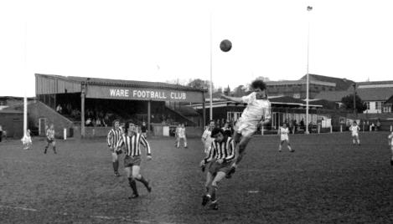
A view of the old Ware ground at Buryfield

Fifteen years elapsed before we met again. We went up to the Premier Division in 1984 and when we came back, the lower divisions were split into Division Two North and South halves which kept us apart. Even after the geographical boundaries were removed, we were placed in Division Three while they remained a step above. However, in 1997/98 they dropped to our level and we lost 2-1 at home on 13th December 1997, but won the return 3-2 on our first visit to Wodson Park, which the club had moved into in 1996 with their old ground built on. We both finished joint seventh that season!

The following year we lost both matches again, but things were improving for us and although we lost there 2-0 in October of 1999 we won the return 3-0 at Merland Rise in March of 2000 and won both matches in the following season by the score of 2-1.

2001/02 was our promotion season and although we won both matches again, the first of these was very fortunate as we trailed there on 15th September 2001 before equalising when a Paul Sears shot bobbled along the ground and then hopped straight over the diving keeper into the net! Moments later Simon Hatton scored from nearly thirty yards and a fine Jamie Sinclair strike into the far corner from a narrow angle ensured a 3-1 win. Simon Huckle then scored twice in the return as we pushed for promotion through League reorganisation which occurred in May 2002.

We didn’t remain in Division One South for long though and were back down in 2004/05 where our opening day opponents were Ware on a sweltering day in August, memorable only for the minute’s silence given to long term supporter Chris Henry. Micky Owen put us ahead that day but we drew 1-1 and the scoreline was repeated at Wodson Park. However in 2005/06 Ware defeated us 7-0 over there in what would prove to be Nigel Bennett’s final game of his 630 for the club and a home 2-1 defeat on 8th April 2006 remains the last time we met.

Since that time Ware have remained at Step Four, just about, and have been transferred back and forth from Southern to Isthmian League. They start this season back in the Isthmian League North where they look forward to renewing rivalries with local rivals Hertford Town once again.

Centre page for results

Centre page for results



Chertsey Town – History
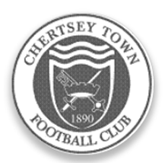
Organised football was evident in Chertsey well over a century ago but county affiliation did not take place immediately. The official founding of the club took place in 1890 when matches were played in the West Surrey League. The first success came in 1897 when the Surrey Junior Cup was secured. A one year gap took place before football resumed in the same competition which eventually became the East and West Surrey League.

A further halt in football took place during the Great War but soon after, in 1919, the club joined the Surrey Intermediate League where it stayed uneventfully, until 1939 and a further break. An invitation to become founder members of the Surrey Senior League was not taken up in 1923 but membership was later assumed, on attaining senior status in 1946.

The club has played at various locations within the parish (Willow Walk, Free Prae Road, Stained Lane and Chilsey Green Road) before settling down at the present home in 1929. The suffix ‘Town’ was added to its title some 21 years later. The ground was donated by Sir Edward Stern as a football ground to the ‘premiere club in the parish’. Next door, a similar trust provides facilities for Chertsey Cricket Club. The main stand was constructed in the mid-fifties; the original clubhouse added in 1960 and the first covered enclosure was built some three years later. Cover behind one goal was added in 1994.

Although Chertsey gained membership of the Surrey Senior League immediately after the Second World War, it was not until the 1959/60 season that success came with the League Championship. This was repeated twice in the next three years, a halcyon period when the League Cup was also won on three occasions. Due to the static nature of Amateur football in those days, the club could not progress to the preferred Corinthian League so, in 1963, it was controversially decided to turn professional and enter the Metropolitan League. Although an entertaining three years were then enjoyed, the cost was too much to bear and a return to lower levels of the Greater London League for one season occurred before a further shift to the Spartan League was made in 1967.

Indifferent results then dogged the club for almost two decades. This situation was briefly relieved in 1974/75 when the club were League and League Cup runners up to an up and coming Farnborough Town. Meanwhile, the fabric of the club was being built up behind the scenes and despite the lack of

prominence on the park, movement was made via the London Spartan (1975/76) and Athenian leagues through to the Isthmian family with a place in Division Two South in 1984. Instant relegation to the Combined Counties League was suffered but, a rejuvenated side won promotion back to the Isthmian ranks within the year winning the League Cup on the way.

The club was rewarded with good league positions but with further promotion denied at first. The worst season after returning to the Isthmians came when the two Division Twos were split in 1991 and a place in the new Division Three had to suffice. The position was quickly rectified with a runners up slot in 1992.

The club also reached the quarter finals of the F.A. Vase, emulating a similar performance in 1987/88. One year later 102 points and a runners up promotion place to Division One was nailed. The League Cup was also secured together with the Carlsberg Trophy in the same campaign along with the League Charity Shield.

Only one campaign was required in Division One before further promotion to the Premier Division. The first season at that level was one of consolidation but the second was more difficult. A late rally was experienced, but was insufficient to avoid the drop to Division One. Two subsequent Division One campaigns were comfortable but the third proved too difficult after a very poor first half of the season.

Relatively respectable positions were attained for the next two seasons and then a return to Division One, taking a place in the revised south section in the Isthmian re-organisation. The side was not able to compete at this level and relegation to Division Two was suffered in 2003. With the dissolution of the division, the club was allocated to Combined Counties in 2006. Good finishes were created regularly over the five terms in that competition. Finishing as runners up in 2011 was good enough on that occasion to secure promotion to Division One Central of the Southern League. Unspectacular, but safe, performances were achieved for two seasons but the relegation was suffered at the end of last season, and with it a return to the Combined Counties League where the club has flirted with further relegation at times.

The club which also has a comprehensive and integrated junior section of boys from all ages is sponsored by Traylen Enterprises; a nearby company that takes a great deal of interest in local community projects. The club now also supports a ladies team who play in the Greater London League.

Chertsey Town’s nickname, the ‘Curfews’ is derived from a locally famous bell that hangs in the nearby St. Peters Church. The bell has rung out the evening curfew, now ceremoniously of course, for over five hundred years.

Matches against Chertsey Town
We have met Chertsey on 49 previous occasions, and results haven’t gone well, over that time, with many defeats on our record. However, in recent seasons there has been an improvement with three wins in our last four meetings and four wins in a row at Alwyns Lane, something we had not achieved at any time previously.

As you might expect though, I’m going to start with the earlier matches. Our first ever match technically between an Epsom team and a Chertsey team were when Epsom met Chertsey Reserves in the Final of the Surrey Junior Charity Cup on 6th April 1907, when an earlier incarnation of our Epsom side won the cup 5-0 at Alexandra Recreation Ground in front of a crowd of around 400.

However, in terms of the two current teams, our first meeting was an Amateur Cup tie at Alwyns Lane on 2nd October 1948, which was drawn 2-2 after 90 minutes, with extra time failing to produce another goal. Kenny Minter and Jimmy Emblem scored Epsom’s goals. Unfortunately Emblem was injured after three minutes of the replay the following Saturday, leaving our boys with ten men, but we still managed to win the replay 2-1 with goals from future Manager Fred Chitty and Jackie Collins.

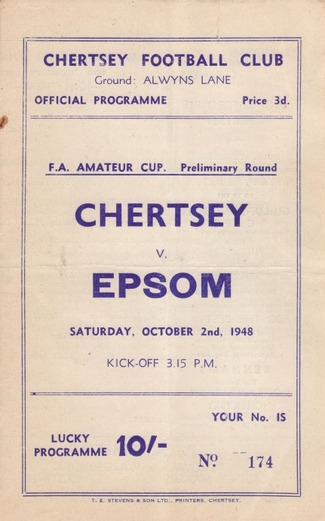
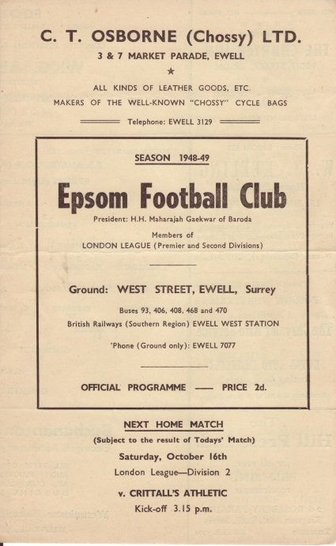
Our next meeting was another Amateur Cup tie two years later on 21st October 1950, when Epsom trailed 4-1 at half-time, but recovered to win the tie 5-4, thanks to two goals from Sid Faggetter, and others from Mick Colwell and Pat Jordan. Tommy Wright

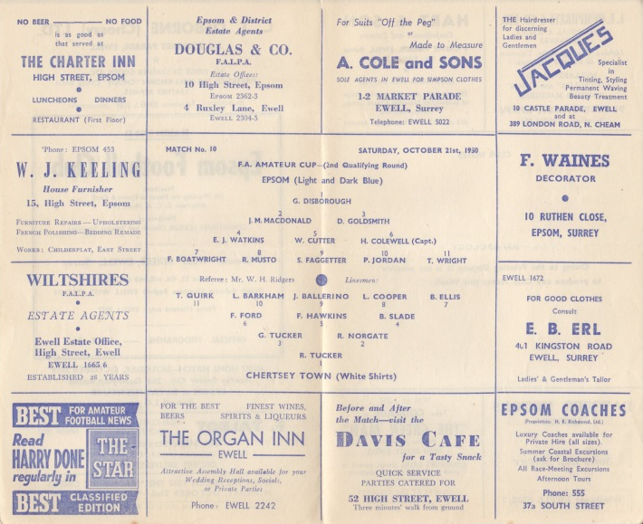
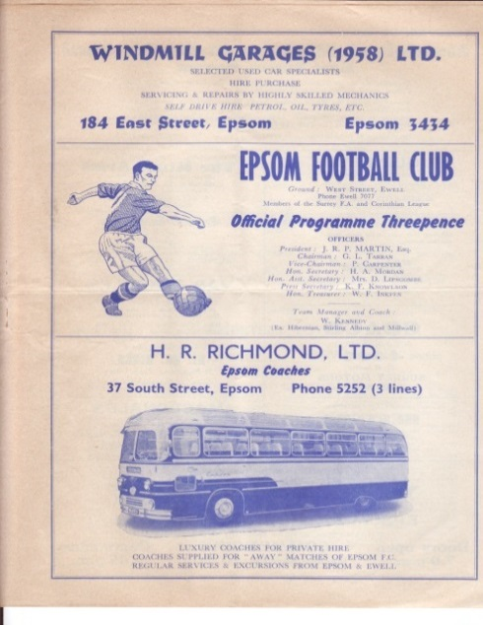
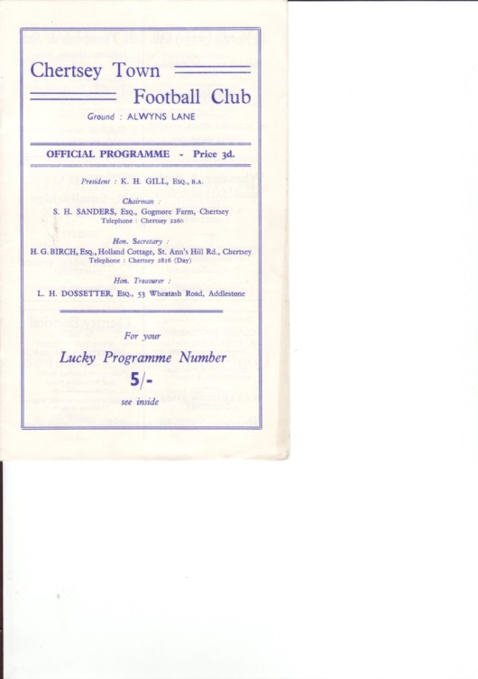
scored the winner that day. In 1959 Chertsey beat us in two competitions, winning 3-2 at West Street in the Amateur Cup, and 4-3 in the Surrey Senior Cup at Alwyns Lane, even though we had led 2-1 at half time.

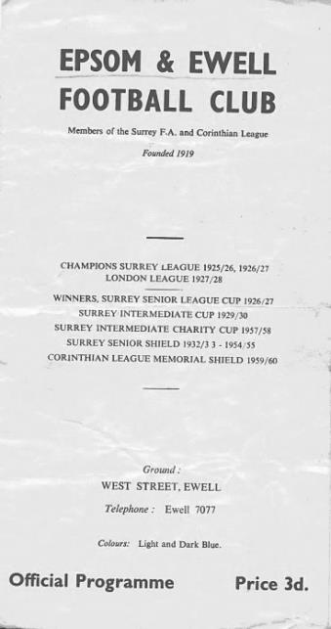
We next met in 1962, and again it was a Surrey Senior Cup tie which was lost by the same 4-3 scoreline, although this contest was at West Street and required extra time at 3-3. We had led 3-2 at the half, through goals by Taz Arnall, Gerry Jenkins and Sid Dobson.

Maybe fortunately, it wasn’t for another 25 years before we met again, once the Blues had been relegated to the Isthmian League Division Two South, when a Luke Harding winner seven minutes from time gave Epsom a 2-1 win.

However, wins were very rare and we would only record four more wins from our next 14 meetings, by which time Chertsey had moved up to compete with the top clubs in the Isthmian League.

By the time of our next meeting it was 2002 and we had just been promoted into the Isthmian League Division One South. This season was not a good one for the Curfews and we won both matches 3-0 as they finished bottom and went down.

We weren’t up there for long though and in 2004/05, by now back in the Ryman League Division Two together, we met four times, failing to win any of them, including an Associate Members Trophy Group game that many supporters completed a sponsored walk to in September 2004!

2005/06 contained an improvement as we beat them 4-2 at Merland Rise with three long range strikes marking the win although by the time of our return fixture eleven days later we had dispensed with the Manager Ray Purvis. This game was best remembered for the award of three penalties to the home side, fortunately they only scored two of them and we escaped with a draw.

We both transferred across to the Combined Counties League in 2006 and we won just one of our next seven matches against them before trailing 2-0 at home on 19th September 2009, but two goals from Ben Hayward followed by a last minute winner from Robbie Burns made for a special and well-remembered celebration! (see picture)

Since then results have been more even and we had the luxury of a Kyle Hough missed penalty, his first in 28 attempts as we defeated them 2-1 at Alwyns Lane in January 2011. However, they had the last laugh, winning the return match 4-1 at our temporary home at Moatside and being promoted to the Southern League at the end of the season.

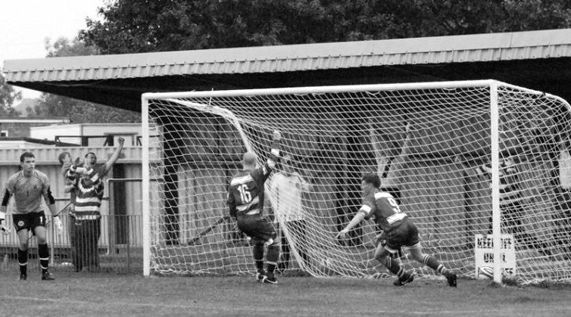
Last season they returned to our League and both clubs won their away fixture in unusual circumstances. We lost 2-1 here to a nine man Chertsey side on 28th October 2014 but won the return fixture on 14th March 2015 by the same score, despite finishing with ten men ourselves. Our last meeting was a 3-0 win at Alwyns Lane in February, which completed a league double, following our 2-1 win here last December.

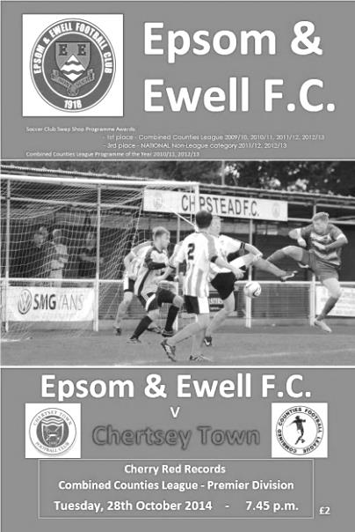
So there we have it. Plenty of matches and if I’m honest, not that many happy memories but you could argue that this makes the good times even more memorable when they happen!

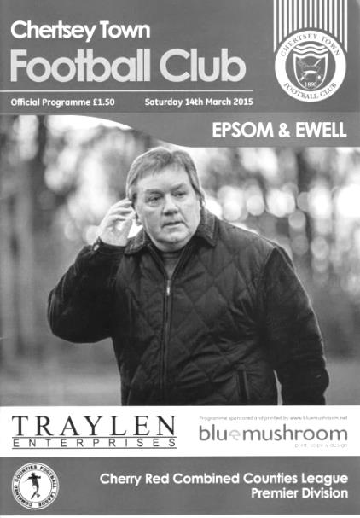

Match and Ball Sponsorships – 2017/18
Opponent | Date | Match Sponsor | Ball Sponsor
Banstead Athletic (FAC) | 06/08/17 | Club President - Stella Lamont
Chertsey Town | 15/08/17
Redhill | 02/09/17 | provisional
Spelthorne Sports | 09/09/17
Horley Town | 12/09/17
Hanworth Villa | 23/09/17
North Greenford United | 28/10/17
Godalming Town | 11/11/17
Farnham Town | 14/11/17
Guildford City | 02/12/17
Abbey Rangers | 16/12/17
Walton & Hersham | 30/12/17
Balham | 20/01/18
Sutton Common Rovers | 03/02/18
CB Hounslow United | 13/02/18
Knaphill | 24/02/18
Camberley Town | 10/03/18
Bedfont Sports | 24/03/18
Colliers Wood United | 30/03/18
Banstead Athletic | 02/04/18
Westfield | 14/04/18
AFC Hayes | 28/04/18 | Club President - Stella Lamont
Surrey Senior Cup |  | Unknown opponents
F.A. Vase 1st Round Proper |  | Unknown opponents
For League, League Cup and Surrey Senior Cup Matches:
Match sponsorship - £40.00 Match ball sponsorship - £25.00. Combined £55.00.
For F.A. Cup and F.A. Vase matches:
Match sponsorship - £50.00 Match ball sponsorship - £30.00. Combined £65.00.

Sponsorship includes: (x2 for match, x3 for match and ball)

Admission, programmes, hospitality and advertising and mascot for the day (if required).

If you are interested, just speak to a Committee Member, or drop me an email at: richard.c.lambert@gmail.com

We also thank our Kit Sponsors
G4 Group

CCL Premier Division Club Directory
ABBEY RANGERS Telephone: 01932-422962 - Colours: Black & White Stripes/Black/Black
Ground: Addlestone Moor, Addlestone. KT15 2QH

A.F.C. HAYES Telephone: 0208-845-0110 - Colours: Blue and White Stripes/Blue/Blue
Ground: Farm Park, Kingshill Avenue, Hayes. UB4 8DD

BALHAM Telephone: 0208-942 8062 - Colours: White & Black/Black/Black

Ground: Colliers Wood United FC - Wibbandune, Robin Hood Way, Wimbledon. SW20 0AA -

BANSTEAD ATHLETIC Telephone: 01737-350982 - Colours: Amber &Black/Black/Black
Ground: Banstead Athletic, Merland Rise, Tadworth. KT20 5JG

BEDFONT SPORTS Telephone: 0208-831-9067 - Colours: Red & Black Hoops/Black/Red & Black
Ground: Bedfont Sports Club, Hatton Road, Bedfont. TW14 8JA

CAMBERLEY TOWN Telephone: 01276-65392 Colours: Red & White Stripes/Blue/Red
Ground: Krooner Park, Wilton Road, Camberley. GU15 2QW

CB HOUNSLOW UNITED Telephone: 0208-577 -9712 Colours: Green/Black/Green
Ground: CB Hounslow Sports Ground, Green Lane, Hounslow TW4 6DH

CHERTSEY TOWN Telephone: 01932-561774 - Colours: Royal Blue & White Stripes/ Blue/ Blue
Ground: Alwyns Lane, Chertsey. KT16 9DW

COLLIERS WOOD UNITED Telephone: 0208-942 8062 - Colours: Royal Blue/Black/Black
Ground: Wibbandune, Robin Hood Way, Wimbledon. SW20 0AA

EPSOM & EWELL Telephone: 01737-553250 - Colours: Royal Blue & White Hoops/Royal Blue/Royal Blue - Ground: Chipstead FC, High Road, Chipstead. CR5 3SF

FARNHAM TOWN Telephone: 01252-715305 - Colours: - Claret & Sky Blue /White/ Claret & Blue
Ground: Memorial Ground, Babbs Mead, West Street, Farnham. GU9 7DY

GODALMING TOWN Telephone: 01483-417520 - Colours: Yellow/Green/Yellow
Ground: Wey Court, Meadrow, Godalming. GU7 3JE

GUILDFORD CITY Telephone: 01483-443322 - Colours: Red & White Stripes/Black/Black
Ground: The Spectrum, Parkway, Guildford, Surrey. GU1 1UP

HANWORTH VILLA Telephone: 0208-831-9391 - Colours: Red & White Stripes/Black/Black
Ground: Rectory Meadows, Park Road, off Hounslow Road, Hanworth. TW13 6PN

HORLEY TOWN Telephone: 01293-822000 - Colours: Claret & Sky Blue/Claret/Claret
Ground: The New Defence, Anderson Way, Court Lodge Road, Horley. RH6 8SP

KNAPHILL Telephone: 01483-475150 - Colours: Red/Black/Red & Black
Ground: Brookwood Country Park, Redding Way, Lower Guildford Road, Knaphill. GU21 2AY

NORTH GREENFORD UNITED Telephone: 0208 422 8923 - Colours: Royal Blue & White/Royal Blue/Royal Blue - Ground: Berkeley Fields, Berkeley Avenue, Greenford, Middx UB6 0NX

REDHILL Telephone: 01737-762129 - Colours: Red and White Stripes/Red/Red
Ground: Kiln Brow, Three Arch Road, Redhill. RH1 5AG

SPELTHORNE SPORTS Telephone: 01932-961055 - Colours: Navy & Sky Blue/ Blue/ Blue
Ground: Spelthorne Sports Club, 296 Staines Road, Ashford Common, Ashford. TW15 1RY

SUTTON COMMON ROVERS Telephone: 0208-644-4440 - Colours: Yellow/ Yellow / Yellow
Ground: Sutton United FC, Gander Green Lane, Sutton. SM1 2EY

WALTON & HERSHAM Telephone: 01932-245263 - Colours: Red & White Trim/Red/Red
Ground: Stompond Lane, Walton on Thames. KT12 1HF

WESTFIELD Telephone: 01483-771106 - Colours: Yellow/Black/Black
Ground: Woking Park, Kingfield Road, Woking. GU22 9BA

Combined Counties League Premier Division
Opponents All-time Records
Inc 12th August | P | W | D | L | F | A | PPG | GD | Best  Win | Worst  Loss
Godalming Town | 1 | 1 | 0 | 0 | 2 | 1 | 3.00 | +1 | 2-1 | -
Spelthorne Sports* | 7 | 5 | 2 | 0 | 15 | 6 | 2.43 | +9 | 6-2 | X
Sutton Common Rovers | 12 | 9 | 2 | 1 | 30 | 14 | 2.42 | +16 | 4-0 | 1-4
Horley Town | 30 | 21 | 5 | 4 | 67 | 31 | 2.27 | +36 | 6-0 | 1-3
Abbey Rangers | 4 | 3 | 0 | 1 | 11 | 4 | 2.25 | +7 | 7-1 | 2-3
Bedfont Sports | 11 | 7 | 2 | 2 | 21 | 12 | 2.09 | +9 | 5-1 | 0-4
Banstead Athletic | 37 | 23 | 6 | 8 | 61 | 37 | 2.03 | +24 | 5-0 | 0-4
Knaphill | 8 | 5 | 1 | 2 | 17 | 9 | 2.00 | +8 | 4-0 | 1-2
Colliers Wood United | 23 | 14 | 2 | 7 | 45 | 34 | 1.91 | +11 | 4-0 | 0-5
Guildford City | 18 | 11 | 1 | 6 | 35 | 22 | 1.89 | +13 | 5-1 | 1-5
Westfield | 21 | 12 | 3 | 6 | 43 | 36 | 1.86 | +7 | 6-1 | 0-4
Farnham Town | 15 | 8 | 3 | 4 | 27 | 25 | 1.80 | +2 | 3-1 | 1-4
Hanworth Villa | 17 | 8 | 4 | 5 | 38 | 27 | 1.65 | +11 | 5-0 | 1-4
Walton & Hersham | 52 | 25 | 11 | 16 | 105 | 99 | 1.65 | +6 | 8-0 | 1-9
Camberley Town* | 90 | 38 | 22 | 29 | 158 | 125 | 1.51 | +33 | 9-1 | 0-4
Windsor | 50 | 20 | 12 | 18 | 92 | 90 | 1.44 | +2 | 4-0 | 0-6
Redhill | 33 | 14 | 2 | 17 | 63 | 69 | 1.33 | -6 | 7-2 | 2-8
Chertsey Town | 49 | 19 | 5 | 25 | 75 | 87 | 1.27 | -12 | 3-0 | 0-7
North Greenford United | 12 | 4 | 2 | 6 | 18 | 22 | 1.16 | -4 | 3-0 | 1-4
AFC Hayes | 10 | 2 | 3 | 5 | 18 | 18 | 0.90 | 0 | 7-0 | 0-3
CB Hounslow United | 4 | 1 | 0 | 3 | 6 | 11 | 0.75 | -5 | 2-0 | 1-5
Balham | - | - | - | - | - | - | - | - | - | -
* includes one abandoned match v Camberley and one loss on penalties v Spelthorne

Salts Super Six Predictor
The Salts Super Six Predictor is live again today and the tickets are on sale at today’s game to the left of the gate. The matches are to be played next Saturday.

The jackpot is already up to £310 which if won would represent the third largest individual prize so far and who knows how much higher it could rise!

The competition is easy to play! To win, you simply need to predict the results of six matches correctly from the three options, fill in the form and make sure it is back with our seller before the deadline on the ticket. The latest fixtures are shown below.

If you are a club regular, you just need to place your name on the sheet, although if you aren’t, then we’ll need a contact number from you too. We will announce any winners on the website within three working days, so don’t worry, we won’t miss you!

Please note that if there is more than one winner, the prize pot would be shared between the winners. All you need to do now is have a go, as many times as you like!
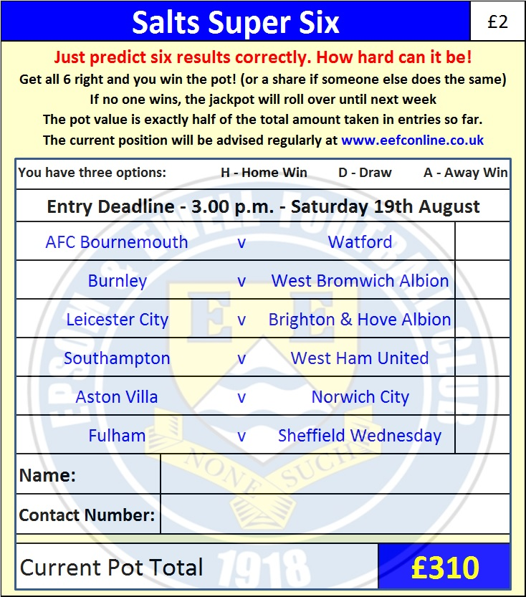

Good luck!

Combined Counties League – Premier Division
Tuesday, 15th August 2017 - Kick-off 7.45 p.m.
Epsom and Ewell  (Royal Blue & White hoops) | V |  | Chertsey Town  (All Red)
Squad | NUMBERS |  | Squad
Colin Harris |  |  | Chico Ramos
Jordan Brooks |  |  | Steve Newman
Cristian Castell |  |  | Ben Geraghty
Franky Law |  |  | Jack Wadmore
Dale Marvell |  |  | John Pomroy
Tom Harland-Goddard |  |  | Joe Adoo-Peters
Ben Dyson |  |  | Steve Brown
© Sam Robinson |  |  | Joe Jones
Joe Loftus-Cheek |  |  | Marcus Mealing
Kyle Hough |  |  | Bundle Mikidi
Rob Hendry |  |  | Andy Crossley
Tayo Ajayi |  |  | Abdul Mohomud
Daniel Rose |  |  | Connor Young
Antony ‘Freddy’ Myers |  |  | Otis Taylor
Jason Nwachukwu |  |  | Connor Cullen
Reisse Griffin |  |  | Shelton Gooden
Matt Robinson
Liam Roberts
Louis O’Brien
Ali Dewar
Ben Hayward
Alistair Turpie
Alex McKay
Jamie Hatfield
Glyn Mandeville | MANAGER |  | Carl Taylor
Matt Smith | ASSISTANT |  | Gary Jenkins
Alex McKay / Jimmy Hendry | COACHES / PHYSIO |  | Dan Dullaway / Megan Jones
REFEREE: M.Coen (Worcester Park)
ASSISTANTS: I.Hempel, J.Ohene
Today’s Match and Match Ball are sponsored by:
The Epsom & Ewell FC Management Committee

OUR NEXT VISITORS TO HIGH ROAD
Redhill or Spelthorne Sports
Cherry Red Combined Counties League – Premier Division
Saturday 2nd September or 9th September 2017

